1. Check Java version

Open terminal and copy following line.

java -version

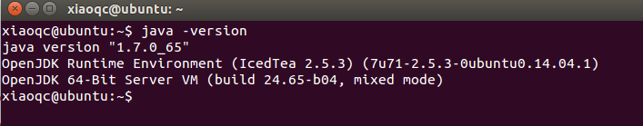

2. Download Tomcat 8.0

<http://mirror.sdunix.com/apache/tomcat/tomcat-8/v8.0.20/bin/apache-tomcat-8.0.20.tar.gz>

3. Extract the download file

cd <path to download folder>

tar -xzvf apache-tomcat-8.0.20.tar.gz

4. Set environment variables

export JAVA_HOME=<path to jdk>

export CATALINA_HOME=<path to tomcat>

5. Run tomcat

$CATALINA_HOME/bin/startup.sh

6. Test tomcat

Try <http://localhost:8080/> in your browser.

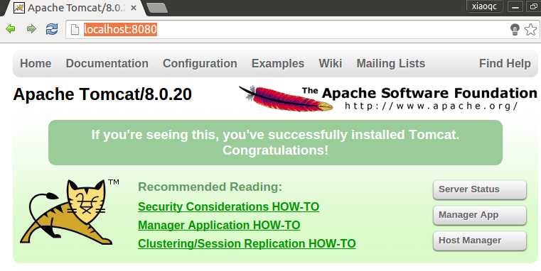

7. Deploy Java servlet

Copy the folder of “queryElastic” from Github

<https://github.com/usc-isi-i2/Social-Viz/tree/master/src/socialVis/Tomcat/>

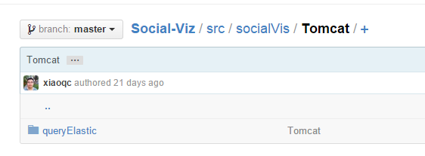

Put the folder under tomcat/bin/webapps

8. Try the webpage

$CATALINA_HOME/bin/shutdown.sh

$CATALINA_HOME/bin/startup.sh

Put this URL to your browser.

<http://localhost:8080/queryElastic/servlets/socialVis/socialVis.html>

Write query on the left panel.

Start Date: 2014-07-01

End Date: 2014-07-31

MaxNode: 50

Click search button.

Wait for tens of second to retrieve data.

Then visualization will show.

